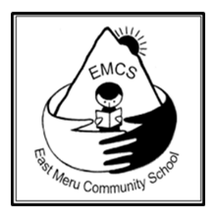
Instructions for non UK sponsors

In each of the following countries we have representatives who handle all of our sponsorship payments. Please contact your relevant representative and they will provide you with all the payment details that you need.
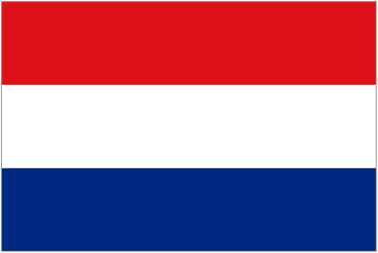
For Dutch sponsors: Contact Hetty Ermers at hettyermers@gmail.com

For Australian sponsors: Contact Helen Mandl at hmandl@fastmail.fm
For New Zealand sponsors: Contact Catherine Birt at crbirt@gmail.com
If you are from a country not represented above: Contact info@eastmerucommunityschool.org

THANK YOU.

